**OUTREACH SCHOOLS EXAMINATION BOARD**

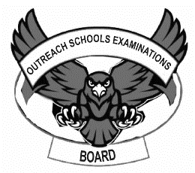 **BEGINNING OF TERM III EXAMINATION 2023**

**PRIMARY ONE**

**READING**

**My name is _____________________________________________**

**I am in __________________________________________________**

**My school is ____________________________________________**

1. **Write the words correctly.**

sub _____________________ bdir________________________

rea_______________________ thermos____________________

tanlp______________________

1. **Fill in the missing sounds.**

Pawpa____ lor____y av____cad____ bi____ycl____

slash____r tr____in wat____r b____s

ho____ g____r____

1. 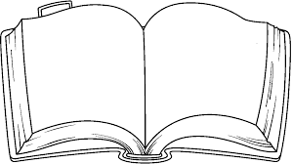**What is this?**

This is a ________________________.

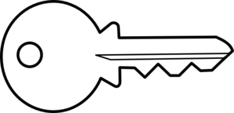

This is a ________________________ .

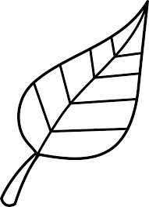

This is a___________________________.

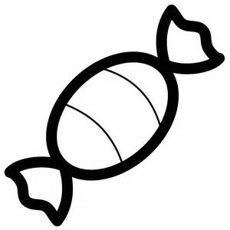

This is a _________________________ .

1. **Match words to their opposites.**

sit down

far near

day go

come stand

up night

1. **Choose the correct words.**
2. The _______________ gives us light.(sun ,son)
3. Did you ________________ food yesterday? (eat, it)
4. Mary is very ________________________ (sick ,seek)
5. The _____________________ is under the table.( cut ,cat)
6. These are _________________________ balls(for ,four)
7. **Where is the ………… ? On, over, near .**

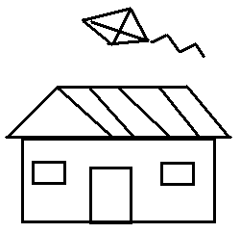

The kite is ______________the house.

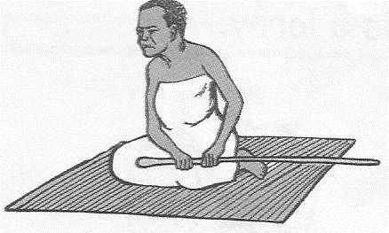

The woman is sitting_____________the mat.

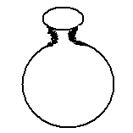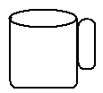

The pot is ___________________ the cup.

1. **Read the story and then answer questions about it.**

**Things we make**

We have different materials for making things we need.

From banana fibres we make dolls and balls.

Mats and bags are made from palm leaves.

We use clay to model pots.

People keep water for drinking in pots.

Carpets and baskets are from papyrus

1. What do we get from clay?

___________________________________________________________

1. We make _________________and _______________ from banana fibres.
2. People keep water for drinking in ___________________________
3. From which material do we make mats?

___________________________________________________________

1. **Give the plurals**

**one many**

conoe ______________

lorry ______________

bus ______________

ship ______________

lady ______________

water ______________

desk ______________

1. **Copy and write.**

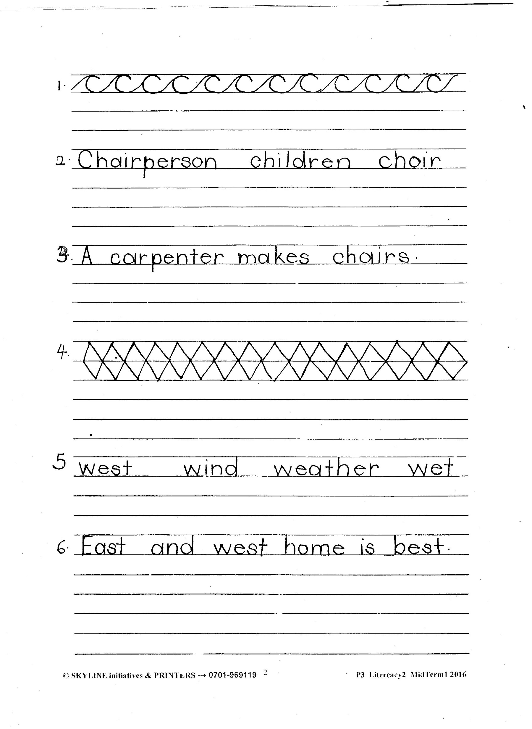

**END**